TDK-Lambda Genesys LAN Instrument Driver Readme
To rate this instrument driver, go to the driver download page on the Instrument Driver Network.

Table of Contents:
1. Overview
2. Required Software
3. Installation Instructions
4. Accessing the Driver in LabVIEW
5. Using the Instrument Driver
6. Configuring the Instruments and Drivers
7. Multi-drop Addressing
8. Automatic Error Checking
9. Custom Error Codes
10. Unsupported Features
11. Restrictions
12. Known Issues
13. Customer Support
14. Revision History

1. Overview

Instrument Driver Technology: LabVIEW Plug and Play (project-style)
Manufacturer: TDK-Lambda
Supported Language(s): LabVIEW release 2018 (x64)
Supported Model(s): All Genesys DC Power Supplies with the LAN option installed
Model(s) Tested: GEN 30-25-LAN, GEN 10-1000-3P208-LAN,
GEN 600-17-3P208-LAN
Interface(s): LAN (Ethernet)
Firmware Revision(s) Tested: LAN rev "LAN:3.1.1.9"

Supported Regional Settings: English and Universal desktops
(period or comma separator for number decimal point)

Certified: Yes
NI Supported: Yes
Source Code Available: Yes

Driver Revision: v1.03
Original Release Date: Nov 1, 2019
Current Revision Date: Nov 1, 2019

2. Required Software
Some software components need to be installed before using this instrument driver.
The minimum versions of these components are listed below, and can be downloaded
from the National Instruments Download Site.

- LabVIEW 2018 development software (or later).
- VISA drivers (included with LabVIEW). Tested with VISA version 17.0.

Refer to the LabVIEW Help for more information about software requirements. You access the LabVIEW Help by selecting Help » Search the LabVIEW Help.

3. Installation Instructions
Obtain a copy of the driver software. It is packaged in a file with a name similar to:
"TDK-Lambda GEN LAN Series.zip"

An example for Microsoft Windows 10:

A) Extract the files from the ZIP file. They should be put into a folder:
"...\ TDK-Lambda GEN LAN Series\ <files> “

B) Use Windows Explorer and navigate to a folder such as:
...\Program Files \National Instruments \LabVIEW 2018 \instr.lib

C) Copy the “TDK-Lambda GEN LAN Series” folder into the “instr.lib” folder.

D) You will now have a file structure such as:

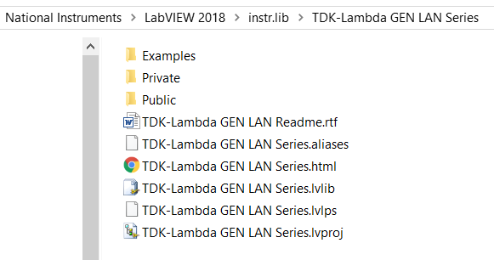

When you run LabVIEW, the driver VIs in the Public folder will be easily accessible as described in the next section.

Alternately, you can open the LabVIEW project (LVPROJ) file in LabVIEW and view and modify all the driver files and palette menus.

Use the menu bar “Tools -> Advanced -> Edit Palette Set...” to edit the driver’s palettes.
See the LabVIEW Help index “Edit Controls and Functions Palette Set dialog box” for instructions on doing this.

4. Accessing the Driver in LabVIEW
A) Open the Functions palette. For example, right-click on a blank place on the VI diagram.
On the Functions palette, navigate:
Functions ->
Instrument I/O ->
Instrument Drivers ->
TDK-Lambda GEN LAN Series->

B) Alternately, click diagram's menu bar:
View -> "Show Functions Palette" and navigate the above menus.

5. Using the Instrument Drivers
LabVIEW:
To verify communication with your instrument and test a typical remote instrument operation, you should first open the Getting Started or Example VIs the instrument driver. Look over each of the controls and set them appropriately.

See the next section 6 for setting up the LAN port connection controls.

After running the VI, check to see that reasonable data was returned and an error was
not reported in the error cluster.

You can right-click any object on the driver panel to see its description.

After you have verified basic communication with your instrument, you might want to customize instrument control for your needs. If your application needs are similar to the Getting Started or Example VI, the simplest means of creating a customized VI is to save a copy of the Getting Started or Example VI by selecting "Save As" from the File menu. You can then modify this example to meet your specific needs.

For more details, reference the LabVIEW Help under:
Help -> VI, Function, and How-To Help.

6. Configuring the Instruments and Drivers
The VISA control on the "Initialize.vi" driver must match the IP address or hostname for the power supply you want to communicate to.

You can see the power supply’s IP address by holding the FOLD button for two seconds and then turning the voltage knob to to see “IP-1, IP-2,..”. See the LAN User Manual for more information on the IP address and hostname,

The “GEN Getting Started.vi” example has a “VISA” control that needs to be configured:

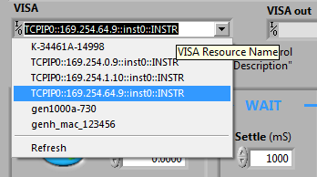

Select the power supply’s VISA Resource Name (example: “TCPIP::192.168.1.10::INSTR”).
If the power supply was added to the NI MAX instrument cache, it will appear in the drop-down list. Otherwise, you may just type in the IP address or hostname in the
“TCPIP::<IP or hostname>::INSTR” format.

7. Multi-drop Addressing
A single LAN “Master” power supply can be linked to other Genesys supplies using an RS-458 daisy-chain. These are called “Slave” supplies. Each supply has a multi-drop address from 0 to 30.

The multi-drop address on each supply can be seen by setting the power supply to local and then holding the “REM/LOC” button for two seconds. Refer to the Genesys User Manual for details.

Every driver has a "VISA" control terminal that is set to the Master’s IP address or hostname.
This must be wired in the first driver "Initialize.vi". Communication with the first instrument is verified when the driver is run.

For any driver used after "Initialize.vi", wiring the "GEN Addr" control is optional.
If the control is not wired, the driver command will be sent to the last instrument that was
addressed. This is called a 'sticky' address or address caching.

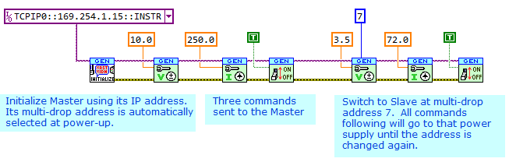

8. Automatic Error Checking
After each command or query, if the supply reports a command or execution error, the error value will be read and returned to the VISA “Error Out” indictor. The error value can be a standard VISA error or to one of the custom codes listed in the tables below.

The user who watches the Wireshark packet analyzer will see the following bus activity with each driver call:

1. A SYST:ERR:ENAB is sent to the addressed power supply. If any pending SYSTEM:ERROR message exist, they are cleared.
2. The driver’s command or query is sent to the addressed supply.
3. If a command was sent, after the power supply has acknowledged the command, the driver sends a SYST:ERR? query.
4. If a query was sent, the driver reads the response. If there was no response (maybe because an illegal query was sent), the driver sends a SYST:ERR? query.

9. Custom Error Codes
Every driver checks for errors and any found are returned in the "error out" cluster. There are three sources of errors and only the highest priority error is returned:

ERROR TYPES
Priority | Type | Description
Highest | VISA Error | Returned by VISA functions such as Write or Read  Examples: After command sent, no response received
 | Instrument Error | Error code returned by instrument. Expected an  "OK" response but received error such as "C01".  Examples: see "COMMAND ERRORS" table below
Lowest | Driver Error | Driver found the command has a bad format or a  response message is corrupted.  Examples: see "RESPONSE ERRORS" table below

The VISA standard allows custom error codes in the range:
-1073999873 to -1074001919 ( BFFC0801 to BFFC0FFF hex)
The instrument errors are formulated in "Error Query.vi".
All returns are errors; there are no warnings. The most common error examples are:

EXAMPLES: INSTRUMENT ERRORS
Decimal Code | Hex Code | Meaning
-1074001663 | BFFC0901 | Execution error "+301". The voltage setting is too  high and conflicts with over-voltage protection
-1074001662 | BFFC0902 | Execution error "+302". The voltage setting is too  low and conflicts with under-voltage limit
-1074001660 | BFFC0904 | Execution error "+304". The over-voltage protection  is too low and conflicts with the voltage setting
-1074001658 | BFFC0906 | Execution error "+306". The under-voltage limit  is too high and conflicts with the voltage setting
-1074001657 | BFFC0907 | Execution error "+307". Attempt to turn the output  ON while a fault is keeping the output OFF
-1074001564 | BFFC0964 | Command error "-100". Illegal command or query
-1074001563 | BFFC0965 | Command error "-101". Invalid character
-1074001560 | BFFC0968 | Command error "-104". Data type error. Command  parameter is wrong type, or query has a parameter but it should not
-1074001555 | BFFC096D | Command error "-109". Missing parameter. Command  requires a value but the value is missing
-1074001442 | BFFC09DE | Command error "-222". Setting out of range. Attempt  to program a setting outside of the model rating

EXAMPLES: DRIVER ERRORS
Decimal Code | Hex Code | Meaning
-1074003951 | BFFC0011 | No response from "ID Query" in "Initialize.vi".  May be an incorrect address setting or the  instrument is not communicating
-1074001904 | BFFC0810 | Could not parse the firmware revision from the “*IDN?” identity string
-1074001902 | BFFC0812 | Could not parse identity fields to get the  model number ("GENvvv-ccc")
-1074001900 | BFFC0814 | Attempt to send query to "Write to Instrument".  Cannot have "?" in command string
-1074001898 | BFFC0816 | Attempt to send command to "Read Instrument Data".  The query string is missing "?"

10. Unsupported Features
The following Genesys capabilities are not supported by these drivers:
- Event and Enable registers (STAT:QUES:ENAB, STAT:OPER:ENAB, *SRE,
and related commands)
- SRQ interrupts
- Calibration commands
- Calibration Date (DATE? query)

11. Restrictions

A. Applicable Genesys Firmware Revisions
The Genesys firmware revision may be read by using the driver:
"Revision Query.vi"

These drivers are fully compatible with Genesys units having LAN firmware revision "2.0" or later
(made after May 2005)

B. Restriction for Service Requesting
These drivers are not compatible with any programs that enable the Genesys Service Request registers (the " *SRE nn" command). This is because the Genesys LAN does not support the VXI-11 Interrupt channel.

12. Known Issues
There are currently no known issues with this instrument driver.

13. Customer Support
For technical support and driver upgrades, please contact the TDK-Lambda High-Power division at:

TDK-Lambda Americas (732)795-4141
Customer Service jeff.bush@us.tdk-lambda.com
405 Essex Road
Neptune, New Jersey, 07753 USA

Or visit our support web page at:
https://us.tdk-lambda.com/hp/sales_html/techsup.htm

Or contact your TDK-Lambda Representative.

14. Revision History
REV 1.03, Nov 1 2019, LabVIEW 2018
Original Release
by Walter Heyck, TDK-Lambda Americas.

